INDEX OF WORKBOOK
I. Basic_lab
1. PenTest Planning, Scoping, and Recon
Lab 1.1 | Scope and RoE Role Play | 4
Lab 1.2 | Linux for Pentesters | 9
Lab 1.3 | Reconnaissance and OSINT | 22
Lab 1.4 | Nmap | 47
Lab 1.5 | Masscan | 59
Lab 1.6 | Nmap -O -sV, EyeWitness, Netcat and NSE | 72
2. Initial Access, Payloads and Situational Awareness
Lab 2.1 | Password Guessing | 98
Lab 2.2 | Metasploit and Meterpreter | 112
Lab 2.3 | Silver | 140
Lab 2.4 | Empire | 162
Lab 2.5 | Payload | 201
Lab 2.6 | Seatbelt | 223
3. Privilege Escalation, Persistence, and Password Attacks
Lab 3.1 | Windows Privilege Escalation | 234
Lab 3.2 | Bloodhound | 243
Lab 3.3 | Persistence | 255
Lab 3.4 | MSF psexec, hashdumping, and Mimikatz | 270
Lab 3.5 | Cracking with John the Ripper and Hashcat | 292
Lab 3.6 | Responder | 321
4. Lateral Movement and Reporting
Lab 4.1 | Running Commands with SC and WMIC | 1
Lab 4.2 | Impacket | 14
Lab 4.3 | Pass-the-Hash | 31
Lab 4.4 | MSBuild | 46
Lab 4.5 | Pivots | 65
5. Domain Domination and Azure Annihilation
Lab 5.1 | Kerberoast | 86
Lab 5.2 | Domain Dominance | 96
Lab 5.3 | Attacking AD CS with ESC1 | 104
Lab 5.4 | Silver Ticket | 121
Lab 5.5 | Golden Ticket | 136
Lab 5.6 | Azure Recon and Password Spraying | 146
Lab 5.7 | Running Commands | 158
Lab 5.8 | Gaining Access and Moving Laterally | 172

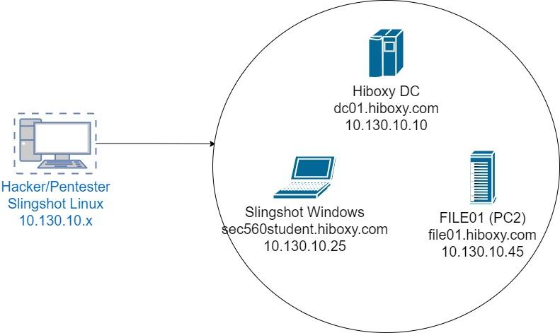
Một số lưu ý (Thực hiện tất cả LAB bôi xanh từ L1 -> L5)
- Đối với các lab có yêu cầu kết nối VPN thì khi thực hiện sẽ cần Hiboxy DC, Slingshot Windows hoặc cả FILE01.
Ví dụ:
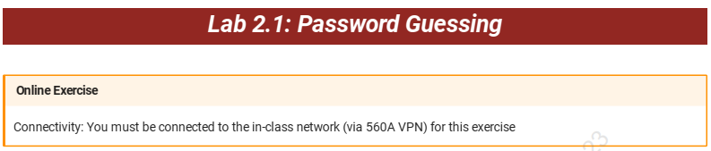
- Còn đối với các lab không yêu cầu kết nối VPN thì chỉ cần thực hiện trên Slingshot Linux và SlingShot Windows
Ví dụ:
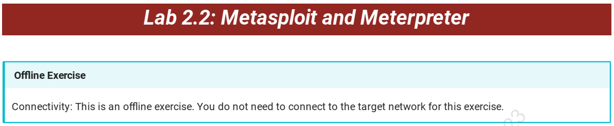
- IP trên thực tế có thể khác một chút so với hướng dẫn.
- Lưu ý:
- Lab 2.6. Seatbelt không cần thực hiện phần 4. Remote usage
II. Extra_lab
Extra Lab
Lab E1 | https://www.vulnhub.com/entry/dc-1,292/ | Requirement  Gain root access on all VMs
Lab E2 | https://www.vulnhub.com/entry/dc-2,311/
Lab E3 | https://www.vulnhub.com/entry/dc-32,312/
Lab E4 | https://www.vulnhub.com/entry/dc-4,313/
Lab E5 | https://www.vulnhub.com/entry/dc-5,314/
Lab E6 | https://www.vulnhub.com/entry/dc-6,315/
Lab E7 | https://www.vulnhub.com/entry/dc-7,356/
Lab E8 | https://www.vulnhub.com/entry/dc-8,367/
Lab E9 | https://www.vulnhub.com/entry/dc-9,412/

